A Project of the University of Connecticut Department of Extension
cttrailcensus@gmail.com ~ www.cttrailcensus.uconn.edu
Farmington and Cheshire Trail Usage Report
By Ryan Faulkner

Background

The Farmington Valley Trails Council has been counting trail uses on the northern section of the Farmington Canal Heritage Trail since 2014. The Connecticut Trail Census which started in 2016 has been counting uses on multi-use trails across the state. In preparation for the coming Plainville connection on the Farmington Canal Trail, the CT Trail Census has completed this brief report analyzing uses from counters on the Farmington and Cheshire portions of trail. The Farmington counter is located off of Red Oak Road and the Cheshire counter is off Jarvis Street. The intention of this report is to give DOT, Trail Planners, and stakeholders an idea of what usage would be on the coming Plainville segment.

Methods & Data

The Connecticut Trail Census calibrates count data using manual counts to adjust for what the counter misses. Infrared counters often undercount bicyclists and pedestrians. Mainly this is from multiple pedestrians crossing the counters line of sight at the same time or a cyclist zipping by. The Farmington Valley Trail Council currently doesn’t calibrate their data to account for undercounting. To keep methods consistent across both datasets, the Farmington counts were multiplied by 1.3 to match the calibration factor used with the Cheshire counter.

When looking at “trail uses” it’s important to understand that uses are not users or trips to the trail. Whenever someone passes the counters line of sight this is counted as a use. Someone making an out and back trip will be counted twice. Since many trails are linear in the state, trail trips mainly are out and back. To get a better estimate of total users of the trail section divide uses by two.

Count data was analyzed for the full calendar years of 2017 and 2018. The Cheshire counter had missing data from August 2st-16th and November 3rd-7th during 2018. Missing counts were replaced with the Average Daily Traffic (ADT). ADT is calculated by taking the average of days with data available.

Results

Farmington: Cheshire:
Year | Total  Use | Average Daily Use
2017 | 60,805 | 167
2018 | 77,331 | 212
Year | Total  Use | Average Daily Use
2017 | 65,598 | 180
2018 | 84,371 | 231

Monthly Uses 2017
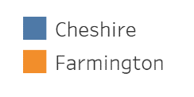
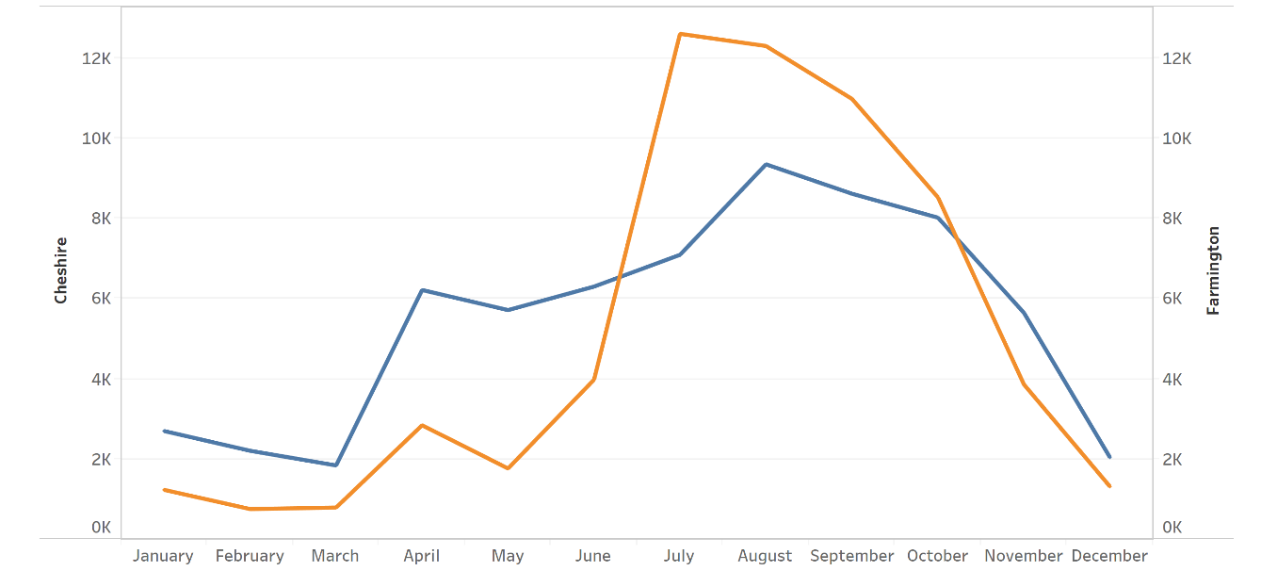
Monthly Uses 2018
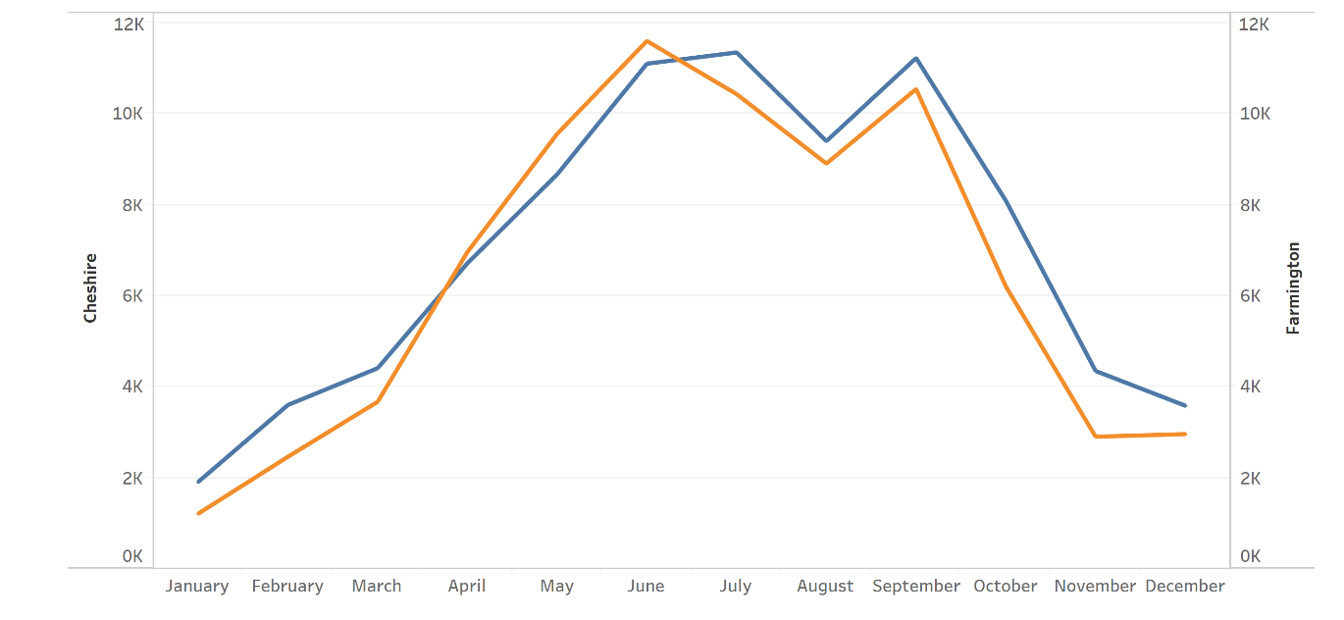

Conclusion

Both trail segments experience significant usage. It’s important to note the trails are still used frequently during the winter. From December of 21st 2017- March 19th, 2018 usage totaled 7,649 in Cheshire and 5,240 in Farmington. While usage averaged 98 per day in Cheshire and 67 per day in Farmington. The months of December to March still accounted for around 10% of trail use for both counters in 2017 and 2018.

New connections clearly impact trail usage. On September 9th, 2018 a new connection opened on the Cheshire trail. This connection opened a contiguous trail between New Haven and Southington. When comparing usage from 2017 to 2018, usage was 8,602 in September of 2017 but 11,220 in 2018. This represents a 28.1% increase in usage year over year. This is just a glimpse of how a new connection impacts trail usage.

Trail usage on the new Plainville connection should be comparable what is seen from the Farmington and Cheshire counts. We expect that usage should increase on both trails due to the connection as seen with the increase in usage in Cheshire after the connection was made in September of 2018.

Lastly, it’s important for DOT and other trail planning stakeholders to know that the Trail Census has a counter on the CT Fastrack trail next to the East Main Street Station.

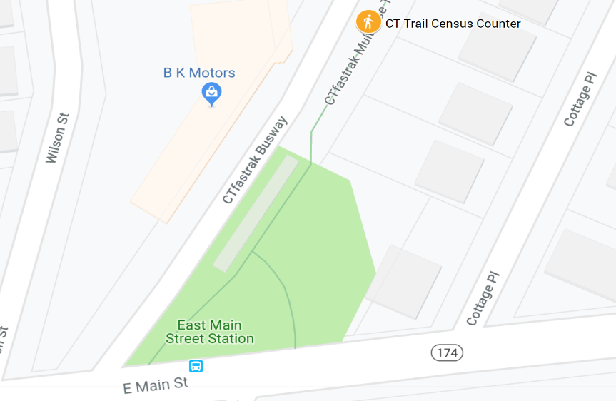

We’ve been getting consistent data from this counter since the end of 2016. Data can be used to demonstrate existing use of the trail system. The Trail Census recommends further studying the Fastrack Trail to understand usage for the entirety of the Trail. Data collected can be used for the Gap Closure Study as a metric to measure how usage is impacted by a future connection to Plainville.

